Bed and Breakfast Packages in Beautiful Havre de Grace
Don’t miss the LAST opportunity to join Lafayette’s Farewell Tour in Maryland! Also, one of the last stops before his return to France on September 9, 2025.
Relax in a historic home while enjoying the festivities of the
200th Anniversary of Lafayette’s Farewell Tour.
July 27 – 29, 2025
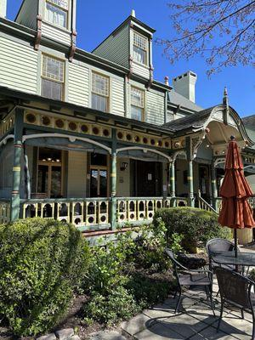
The Vandiver Inn
301 South Union Avenue, Havre de Grace, MD, 21078 (410) 939-5200
www.vandiverinn.com/bogo
Receive your first night's stay at regular price, and receive the next (adjacent) night at 1/2 off!
Please call us at (410) 939-5200, or email frontdesk@vandiverinn.com
PLEASE READ:
BOGO not available for online reservations. FIRST NIGHT CANNOT BE A FRIDAY.
BASED ON AVAILABILITY. CAN NOT BE COMBINED WITH OR REPLACE ANY OTHER PROMOTIONS, DISCOUNTS, PREVIOUSLY BOOKED RESERVATIONS, Booking.com, etc.), OTHER OFFERS, "PROMISES" OWNERS MADE AT A BAR, GOVERNMENT OR GROUP RATES. Guests cannot change rooms. If daily rates differ, the higher of the two will apply.

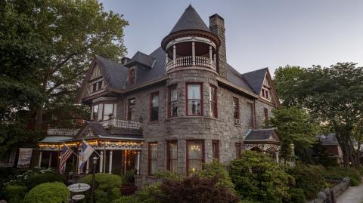

Spencer Silver Mansion
200 S Union Avenue, Havre De Grace, MD 21078 (410) 939-1485
www.spencersilvermansion.com
10% off any room when two nights are taken
Other packages are available on the website.
Please call to receive discounted rate.

Other Accommodation Options Near By
Stay Over | Harford County Tourism, MD

