**1825 Gala, Wednesday 4/9/2025 6:30-9:30pm**

701 Chartres Street New Orleans, LA 70116

We have secured the most special of special Lafayette related venues in the South for our 1825 Gala. The Cabildo now serves as the Louisiana State Museum, a very popular venue in New Orleans that hosts many large events. We’re delighted to present the exclusive premier of the Cabildo’s *Lafayette Exhibit* at the Louisiana State Museum, a rare glimpse into the life of one of history’s most captivating figures, General Lafayette, and his significant contribution to our American independence and his visit to Louisiana in 1825.  Our Bicentennial is an excellent opportunity for you or your organization to support this important event. A portion of each gala ticket goes toward sponsoring the Lafayette exhibit at the Cabildo Museum.

The 1825 Gala will feature a 5-star chef-curated dining experience, presented through elegant heavy hors d'oeuvres stations and complemented by a full open bar. The French Ambassador plans on attending. VIP Dignitaries will welcome us, Lafayette (played by the premier Lafayette interpreter Mark Schneider of Colonial Williamsburg) will speak. The Cabildo has many exhibit rooms which we are free to explore during the gala. (Dress: Business <coat & tie> or Cocktail party attire / Period attire is definitely **encouraged**).

**CABILDO** 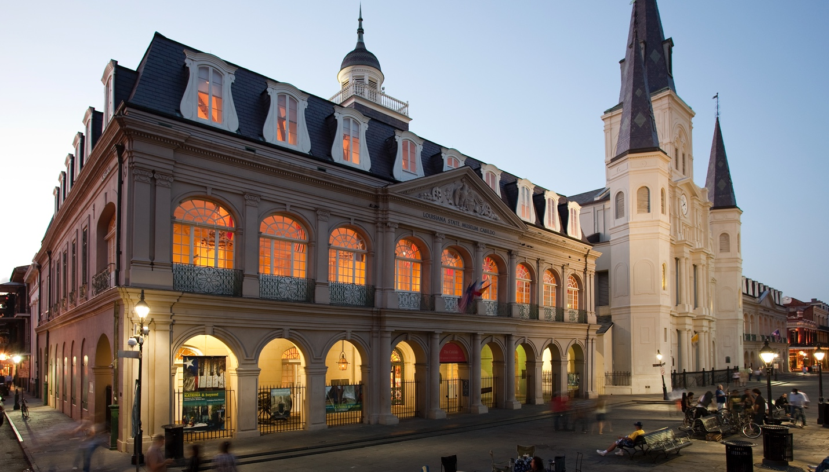

The Cabildo was built under Spanish rule between 1795 and 1799, following the Great New Orleans Fire of 1788 which completely destroyed the structure that stood on the property. Designed by Gilberto Guillemard, who also designed the neighboring St. Louis Cathedral and the Presbytère, the Cabildo was the site of the Louisiana Purchase transfer ceremonies in 1803, which finalized the United States’ acquisition of the Louisiana Territory and doubled the size of the fledgling nation.  
  
The Cabildo served as the center of New Orleans government until 1853 when it became the headquarters of the Louisiana State Supreme Court, where the landmark*Plessy v. Ferguson* decision originated in 1892. The building was transferred to the Louisiana State Museum in 1908 and has since served to educate the public about Louisiana history.  
  
In 1988 the Cabildo was severely damaged in an inferno and, within five years, the landmark was authentically restored with 600-year-old French timber framing techniques. It was reopened to the public in 1994, featuring a comprehensive exhibit on Louisiana’s early history.

LAFAYETTE’S CONNECTION

A history that included Lafayette!!!! In 1825, the city offices were transferred temporarily elsewhere, and the historic building underwent a metamorphosis. A richly appointed parlor took the place of the City Council room; the powder magazine became a fine dining room and the mayor’s office, the secretary's office and the office of the treasury proper, were converted into suitable rooms. The walls were painted with rich and good quality paint. The city’s wealthy residents loaned their best furniture for Lafayette’s comfort- nothing was spared to furnish properly what became known as “The House of Lafayette”.

The Cabildo was where Lafayette slept, met with individuals and groups of dignitaries and citizens every day, and ate all his meals while in New Orleans.

In 1825 Lafayette attended a ball at the Theatre D’ Orleans ballroom, where 800 ladies danced! This building unfortunately no longer exists like it once did.

The Cabildo is fully wheelchair accessible with elevator access to each floor.

The Cabildo serves as our venue on Wednesday evening for our 1825 Gala as well as Saturday’s Lafayette’s address to the Citizens of New Orleans from the second floor Balcony.