**ADRIENNE’S SALON**

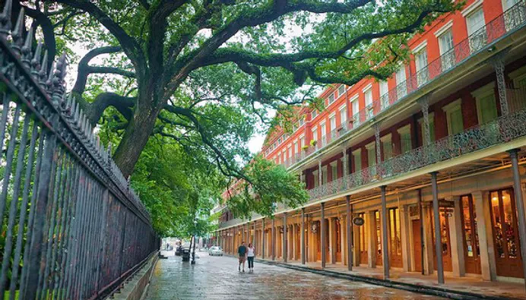

Historic Pontalba Building

**Thursday April 10, 2025 evening’s dinner** is purposely left open (the only evening left open), as we anticipate that attendees will wish to visit a restaurant of their choosing. We recommend that you make a reservation immediately, as the quarter of a million festival goers have the same idea. Or, you can attend the French Quarter Festival to enjoy New Orleans style food at numerous booths keeping in mind that FQF ends at 7pm. Be sure your dinner is finished by 7pm, to attend the

**Exclusive Invitation Only “Adrienne’s Salon” AFL *Boissons le Dessert* Party**  (“drinks and dessert”) The American Friends of Lafayette – Louisiana Committee is hosting a party for AFL members and friends at an historic Pontalba Apartment unit, whose balcony overlooks beautiful Jackson Square, the Cabildo, the St. Louis Cathedral and the Mississippi River. This is our gift to you, and no ticket purchase is needed. Salonnières Marquise Adrienne de Lafayette is our hostess and dessert and drinks will be served. Adrienne will speak about her incredible life. Exact address will be provided at event registration. <Dress: Nice casual>

LAFAYETTE’S CONNECTION

In 18th century France, salons were formal social gatherings driven by discussion, particularly around literature, politics and philosophy. These privately organized events helped to foment, circulate and popularize revolutionary ideas. By the last quarter of the 18th century, the salons had become de facto universities or tutorial groups, specializing in Enlightenment ideas and philosophy. Many salons focused on an item of literature, such as a text by one of the philosophes or a recent essay or pamphlet.

After the American victory, Lafayette and Adrienne hosted a very popular salon on Monday evenings at their extravagant Parisian home, which became known as the de facto headquarters of Americans in Paris. Adrienne’s salon hosted Benjamin Franklin, John and Abigail Adams, John Quincy Adams, Thomas Jefferson, and John and Sarah Jay—as well as liberal members of the French nobility.