LAFAYETTE’S SPEECH
Saturday April 12, 2025 12:25 pm sharp
Lafayette addresses the public from the Cabildo’s Balcony, scheduled for 12:25pm sharp during the 20-minute set break of the French Quarter Festival stages. After some pomp and circumstance, Lt. Governor Billy Nungesser will introduce Lafayette. If weather is poor, the fallback time is 2pm. This event is free and the public is heartily welcomed. It is recommended that you are in front of the Cabildo by 12 noon. <Period attire is welcomed>
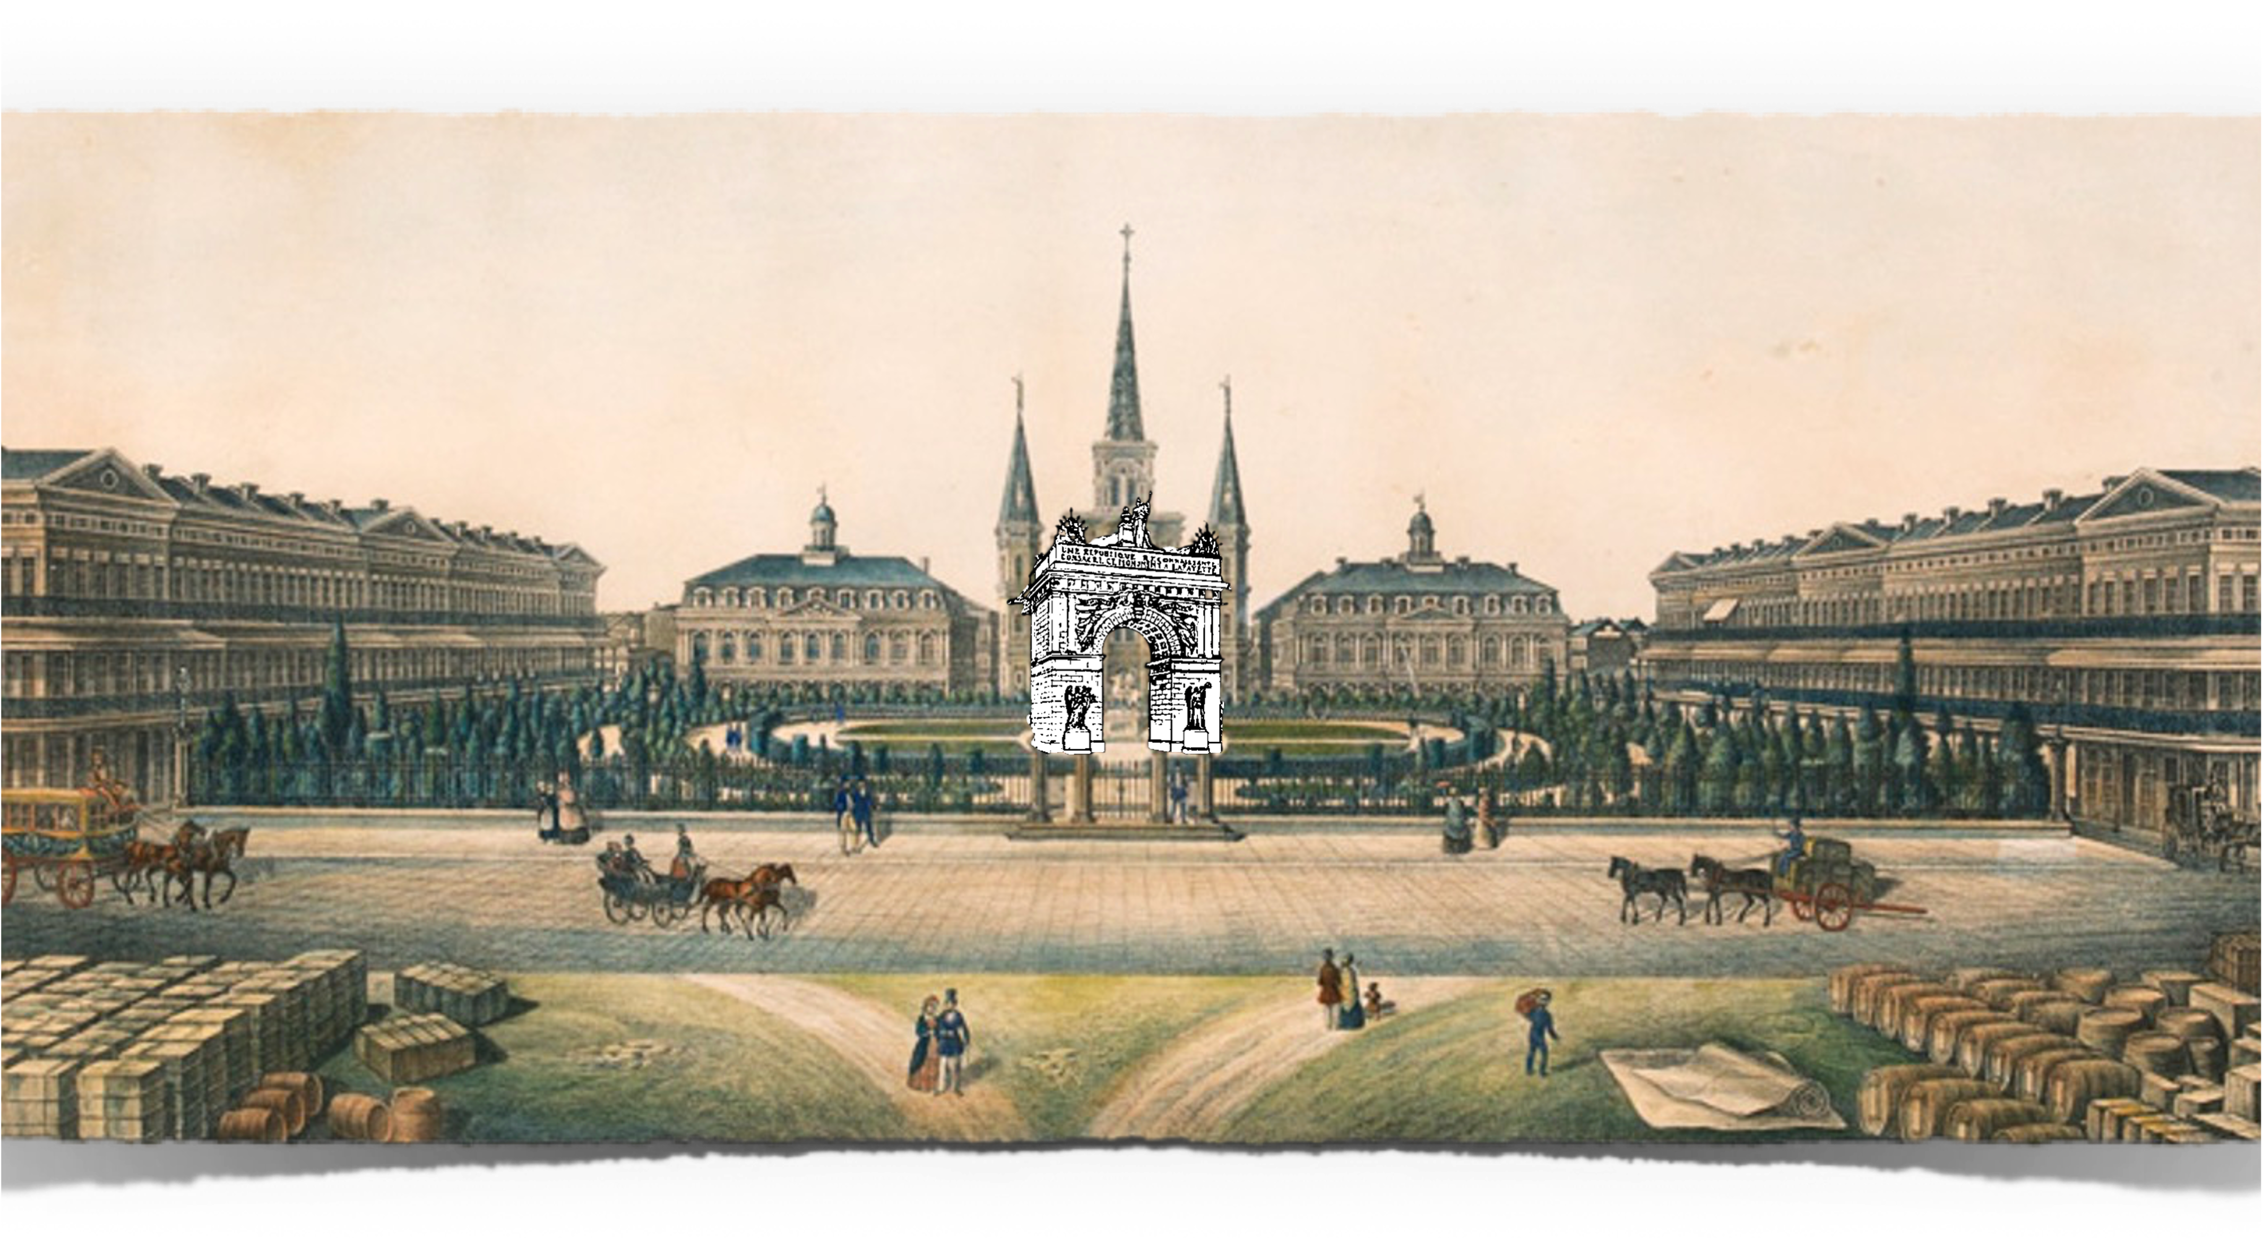

LAFAYETTE’S CONNECTION
A procession of carriages carried everyone to New Orleans, where the City’s Mayor welcomed Lafayette and Lafayette spoke, all under a great triumphal welcoming arch. An imposing arch of Triumph was erected in the center of the square in front of the Cabildo. It was 68 feet high with a massive 40-foot arch. It was decorated with colossal statues of Justice and Liberty. 24 stones each decorated with a gilded bronze star represented the then twenty-four states of the Union. Upon the upper pedestal was written on one side in English and the other in French “A grateful republic dedicates this monument to La Fayette.”
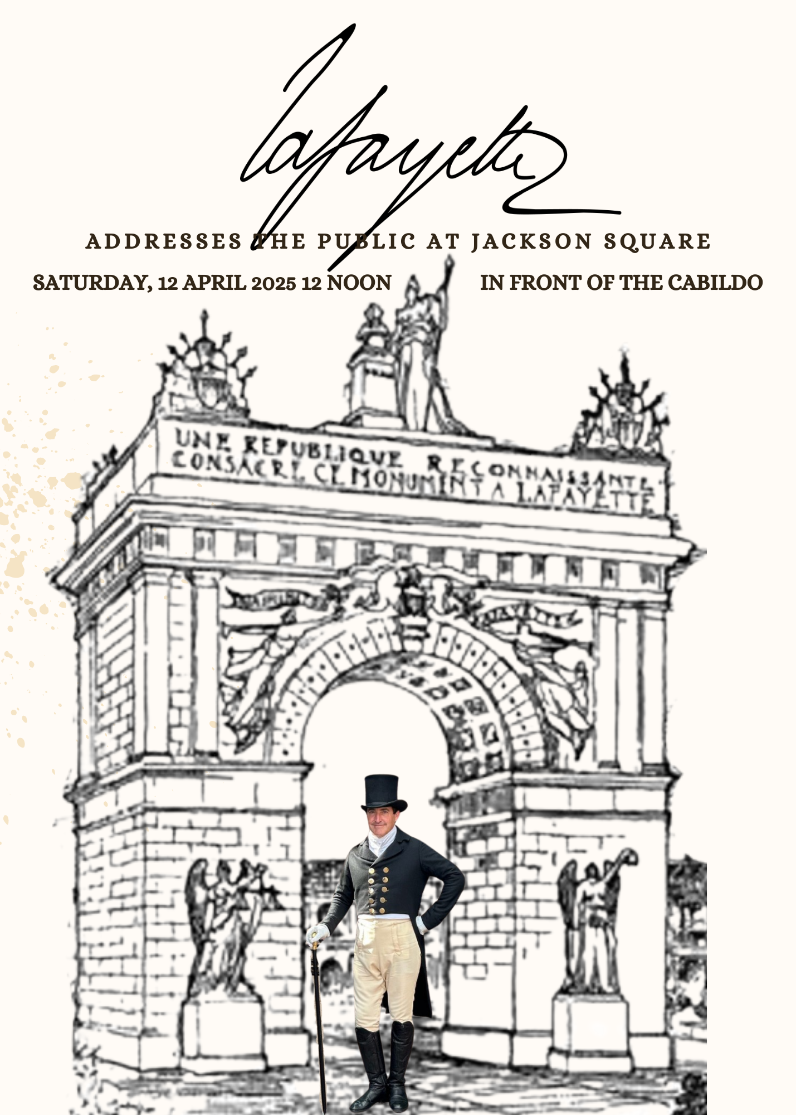

After General Lafayette was shown his accommodations at Lafayette House (the Cabildo), he was informed that the troops were about to march to salute him. Lafayette went out onto the Cabildo balcony, where he reviewed the grenadiers, gunners, dragoons, the Frankish, the light infantrymen, the Union Guards, the riflemen, the New Orleans Guards, and the Lafayette Guards who all marched past the General with great military precision. Although the rain had soiled the rich uniforms of the troops, they looked elegant. The band played patriotic songs.

Last but not least, came ninety Choctaw warriors marching according to their custom in single file. Lafayette was very moved to see that they had sought to inform him that his name was known by warriors of the most remote Indian Nations, and that the local authorities had admitted into the ranks of militias these brave Indians who had been America’s recent allies in the Seminole war.

CABILDO 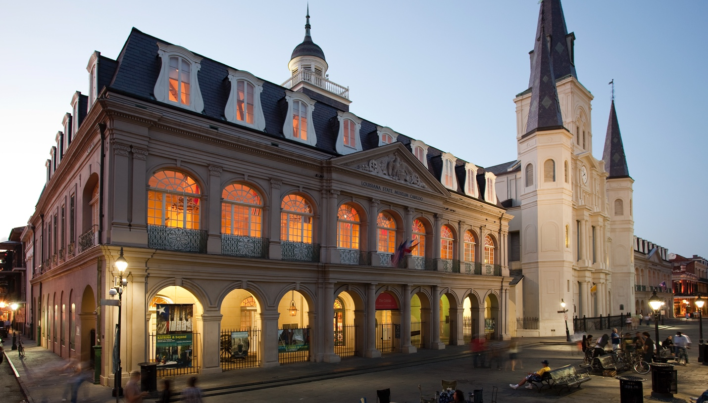

701 Chartres Street New Orleans, LA 70116 - The Cabildo was built under Spanish rule between 1795 and 1799, following the Great New Orleans Fire of 1788 which completely destroyed the structure that stood on the property. Designed by Gilberto Guillemard, who also designed the neighboring St. Louis Cathedral and the Presbytère, the Cabildo was the site of the Louisiana Purchase transfer ceremonies in 1803, which finalized the United States’ acquisition of the Louisiana Territory and doubled the size of the fledgling nation.
The Cabildo served as the center of New Orleans government until 1853 when it became the headquarters of the Louisiana State Supreme Court, where the landmark Plessy v. Ferguson decision originated in 1892. The building was transferred to the Louisiana State Museum in 1908 and has since served to educate the public about Louisiana history.
In 1988 the Cabildo was severely damaged in an inferno and, within five years, the landmark was authentically restored with 600-year-old French timber framing techniques. It was reopened to the public in 1994, featuring a comprehensive exhibit on Louisiana’s early history.

LAFAYETTE’S CONNECTION
A history that included Lafayette!!!! In 1825, the city offices were transferred temporarily elsewhere, and the historic building underwent a metamorphosis. A richly appointed parlor took the place of the City Council room; the powder magazine became a fine dining room and the Mayor's office, the secretary's office and the office of the treasury proper, were converted into suitable rooms. The walls were painted with rich and good quality paint. The city’s wealthy residents loaned their best furniture for Lafayette’s comfort- nothing was spared to furnish properly what became known as ”The House of Lafayette”.
The Cabildo was where Lafayette slept, met with individuals and groups of dignitaries and citizens every day, and ate all his meals while in New Orleans. The Cabildo/ the Louisiana State Museum intends on having a Lafayette exhibit, but plans are still unknown at the time of the ticket release.
The Cabildo is fully wheelchair accessible with elevator access to each floor.
The Cabildo serves as our venue on Wednesday evening for our 1825 Gala as well as Saturday’s Lafayette addressing the Citizens of New Orleans from the second floor Balcony.

