**LAFAYETTE IN NEW ORLEANS HISTORICAL PAGENT**

Thursday April 10, 2025 9:30am – 4pm

Thursday is evolving into an impressive **not to be missed** day, chock FULL of a who’s who list of historical dignitaries who met with Lafayette while in New Orleans in 1825 and what they did and said! Activities on Thursday include: an Immersive Historical Reenactment performance, Lafayette’s Welcome Ceremony at Chalmette Battlefield with time to tour a portion of the Battle of New Orleans exhibit followed by a late lunch cruise on the Mississippi River on the Steamboat Natchez where you will sail on a modern replica of the same ship Lafayette traveled on from Mobile, Alabama to St. Louis, Missouri. While we won’t be traveling quite that far, you will hear Lafayette tell you what his trip on the Natchez was like, which at times was quite harrowing.

**Volunteer participants dressed in period attire** are heartily welcomed and needed to make the morning even more authentic! Please let us know by emailing us at [afl.louisiana@gmail.com](mailto:afl.louisiana@gmail.com) if you will come in period clothing and would like to be a volunteer participant. You will receive emails regarding scheduling and how you can help.

Our very best efforts in creating this amazing commemorative day necessitated us to flip the historical timeline around; to our absolute delight we managed to work everything in! (Thursday’s ticket includes entrance fee, lunch, steamboat cruise, and round-trip motor coach transportation from New Orleans). < Dress: Comfortable casual (Lafayette t-shirt suggested) but period attire is welcomed, of course! >

Imagine – a dusty old book published in 1826 is discovered just in time to guide us in planning our programs on Thursday and Friday! This mighty book, containing every speech given to and by Lafayette in Louisiana, along with additional details not previously known, has expanded our commemoration 1000-fold!

Meanwhile, word of Lafayette’s return in 2025 reached the ears of local persons who understand the importance of teaching the youth of Lafayette’s lasting impact. They offered to plan an event for the area school children to experience first-hand Lafayette in his glory! Thursday’s activities include bringing Lafayette and his entourage to over 1000 school children at an indoor venue strictly for this purpose! You must have a ticket to attend this special theatrical portion of the morning as we are subject to the venue’s capacity limitations. To educate that many students, there will be three, back-to-back theatrical performances.

**"STEP INTO THE PAST, LIVE THE LAFAYETTE LEGACY!" THEATRICAL PRODUCTION**

Buckle up (and fuel up) because we are all invited to share our Lafayette passion with the youth of the New Orleans’ area on this **not to be missed day**! After eating breakfast on your own, we will load onto motorcoach buses and be transported to Docville (*Meraux, Louisiana*) in St. Bernard Parish where we will join approximately 350 students for the last of three Immersive Historical Reenactment performances, transporting guests back to 1825. We will start the student’s day off with a bang with General Lafayette speaking to them about his beliefs, his lifetime of activism and how they are the future of our great country. We will step back through time and hear short speeches given by representatives of the numerous groups of citizens who visited with Lafayette 200 years ago. What a wonderful opportunity to educate so many young people about Lafayette! This indoor event will use state of the art video and audio technology.

At the time of the ticket release, plans are still being finalized. We are so very excited about this opportunity!!!

LAFAYETTE’S CONNECTION

It was announced that General Lafayette would receive visits every morning between eleven and three o’clock at the “House of Lafayette” i.e. the Cabildo. A confluence of ladies and gentlemen daily availed themselves of the opportunity offered of seeing and conversing with the Guest of the Nation. Deputations of many groups also visited the General; speeches of those groups and Lafayette’s responses were published and make up the foundation of the theatrical production.

**LAFAYETTE’S WELCOME CEREMONY AT CHALMETTE BATTLEFIELD**

1 Battlefield Rd, Chalmette, LA 70043

After the special private Immersive Historical Commemoration performance, we will load onto motorcoach buses and be transported the short distance to Chalmette National Battlefield, where the Battle of New Orleans was fought 10 years prior to Lafayette’s arrival. This is where the General first stepped foot in Louisiana and was formally welcomed by the Louisiana governor and other dignitaries.  We are combining two welcome ceremonies into a single one which will include the governor’s address, the City of New Orleans’ Mayor’s address and other dignitaries. Lafayette will respond to the addresses and also review the troops. Lafayette will lay a wreath in remembrance of those who fought and perished at the Battle of New Orleans defending our country against British forces.

Activities at the all outdoor Battlefield are free and open to the general public. (No transportation provided without a purchased ticket.) Some time is open to allow for touring a portion of Chalmette Battlefield.

At the time of the ticket release, plans have not been finalized with the National Park Service. This is an outdoor event, so come prepared for the impact of weather at the Battlefield, although a rainout back up location is being organized at Docville but not yet confirmed.

Chalmette Battlefield is where the Battle of New Orleans was fought on January 8, 1815, between the British Army and the United States Army under Brevet Major General Andrew Jackson, roughly 5 miles (8 km) southeast of the French Quarter of New Orleans.

The battle took place 15 days after the signing of the [Treaty of Ghent](https://en.wikipedia.org/wiki/Treaty_of_Ghent), which formally ended the [War of 1812](https://en.wikipedia.org/wiki/War_of_1812), on December 24, 1814, though it would not be ratified by the United States (and therefore did not take effect) until February 16, 1815, as news of the agreement had not yet reached the United States from Europe.[[8]](https://en.wikipedia.org/wiki/Battle_of_New_Orleans#cite_note-9) Despite a British advantage in numbers, training, and experience, the American forces defeated a poorly executed assault in slightly more than 30 minutes. The Americans suffered 71 casualties, while the British suffered over 2,000, including the deaths of the commanding general, Major General Sir Edward Pakenham, and his [second-in-command](https://en.wikipedia.org/wiki/Second-in-command), Major General Samuel Gibbs.

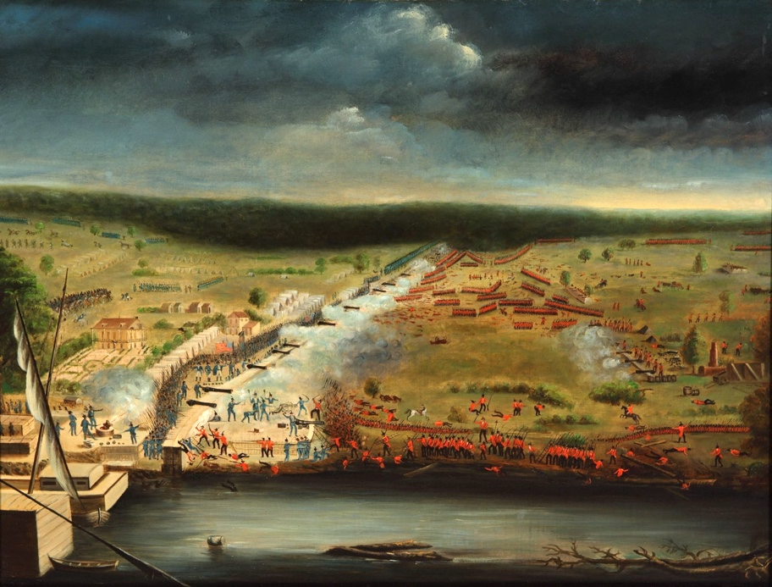

LAFAYETTE’S CONNECTION

Sometime during the night, the Steamboat Natchez arrived at the foot of the Chalmette battlefield, just downriver from New Orleans. This was near the famous lines of the 1815 Battle of New Orleans, where 12,000 elite English troops were crushed by several hundred men, half of whom were carrying arms for the very first time.

On the morning of April 11, 1825, General Lafayette disembarked to the sound of artillery and to the cheering of a considerable throng who, despite the inclement weather and the distance from the City, filled the embankment. The group were astonished by being spoken to in French.

The riverbank appeared covered with men in French uniforms who greeted the General with whoops of Vive la liberté, Vive Lafayette!! For a moment the General believed he had been transported to his homeland France.

The governor officially welcomed Lafayette with a heartfelt speech, depicting former Frenchmen enjoying a freedom that was still impossible in France.

**STEAMBOAT NATCHEZ**

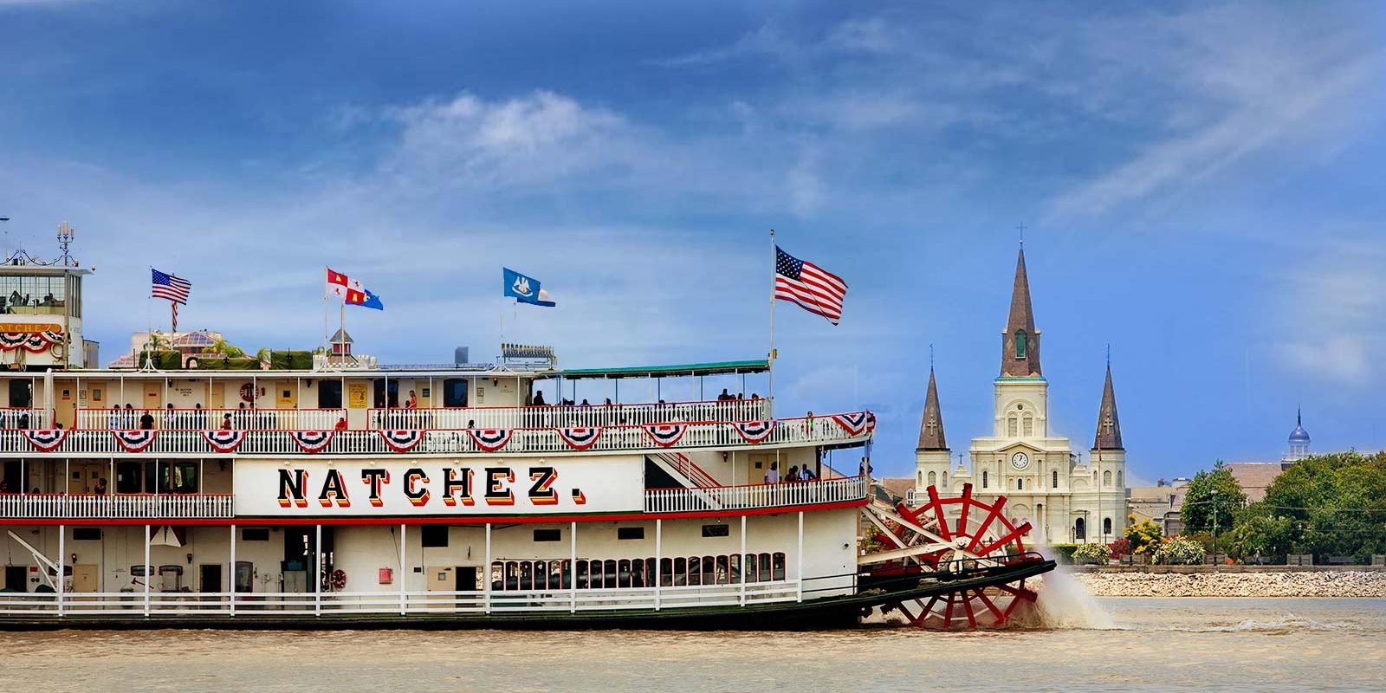

**Steamboat Natchez Lunch Cruise**

400 Toulouse St, New Orleans, LA 70130

And we are not done yet! Lafayette travelled to New Orleans on the Steamboat Natchez. We will be transported from Chalmette Battlefield to the Natchez boarding area. Enjoy lunch on the “replica” Steamboat Natchez while cruising on the Mississippi River with Lafayette.  After this incredible morning, Lafayette will talk briefly about his experiences traveling by steamboat. He will leisurely enjoy cruising with his entourage, enjoying a lunch together with ticketholders and be available to interact with individuals. Think of the photo opportunities! (Lunch on the Natchez/transportation to the school venue, the Battlefield and to the Natchez are included). Dress: <Comfortable casual (Lafayette t-shirt suggested) but period attire is welcomed.>  Come prepared for the impact of weather at the Battlefield, although a rainout back up location is being organized but not yet confirmed.

Come aboard and enjoy New Orleans hospitality… Paddlewheel Steamboat Style! We will journey down the mighty Mississippi, see captivating views of the French Quarter fade into the distance as the joyful tunes of traditional jazz carries you down the river.  An historical lecture on Lafayette’s time on the steamboat Natchez is planned. Stroll the multiple decks, explore the beautiful, refinished interiors and savor the leisurely two-hour cruise that will give you panoramic views of the Mississippi River and the many unique sites along the way, with live narration. The Natchez’s Louisiana flavored menu consists of local favorites – red beans and rice, fried catfish, jambalaya, salad, New Orleans style bread pudding, and more. We will be in the first of two lunch sessions. You will get to hear Lafayette tell you of his journey on the Natchez, which at times was quite harrowing.

True to tradition in every detail, boarding the NATCHEZ makes you feel as if you have entered another era. The captain barks his orders through an old-time hand-held megaphone. The calliope trills a melody into the air while the great wheel, 25 tons of white oak, churns the heavy waters of the Mississippi. You soon find yourself slipping into a sense of the old, vast, and timeless river.

All transportation is included in the ticket price. Due to the private venue’s capacity limitations, tickets are limited. However, you are welcome to join us at the Chalmette Battlefield and purchase your own Natchez ticket for the later lunch cruise, transportation and parking on your own.

LAFAYETTE’S CONNECTION

The steamboat Natchez was fitted out with every convenience to convey Lafayette to New Orleans and up the Mississippi River to St. Louis, Missouri. After attending the Mobile Alabama ball, Lafayette and his entourage boarded the Natchez, which set a course for New Orleans. She stopped at the Chalmette Battlefield, where the Governor welcomed Lafayette to the state and Lafayette spoke.