**MAGNOLIA MOUND MUSEUM AND HISTORIC SITE**

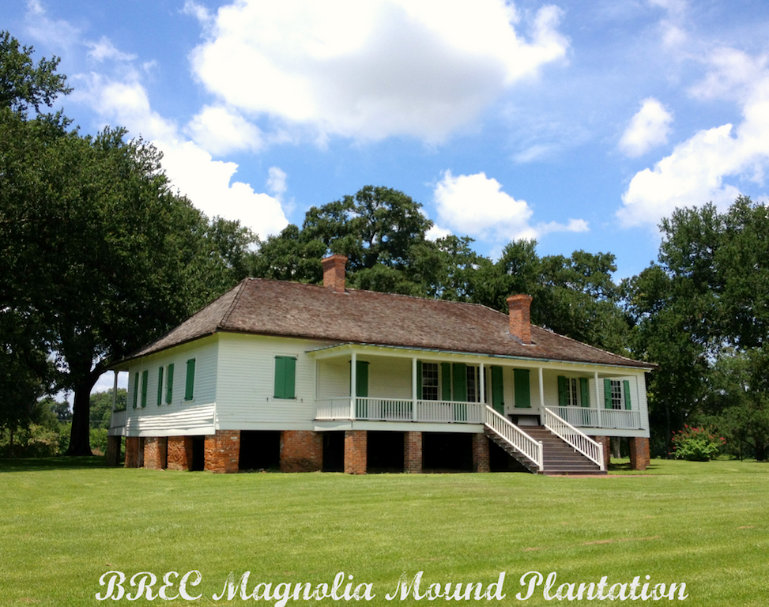

2161 Nicholson Drive Baton Rouge, LA 70802

Friday April 11, 2025

We have reimagined Lafayette’s very brief Baton Rouge visit, so pardon (and enjoy!) our liberties. BREC and the Friends of Magnolia Mound are hosting us at Magnolia Mound Plantation, home of Lafayette’s great friend Armand Duplantier and now part of the Baton Rouge Park system. Duplantier is scheduled to be with us.

We will travel by coach bus from New Orleans to Baton Rouge and transportation is included in the cost of our tickets.

This event is open to the public and The Friends of Magnolia Mound will sell tickets to those who wish to transport themselves. This event is not included in the Petite package, but individual tickets (including transportation) may be available a la carte at a later time. If you purchase the Grandiose package or the a la carte ticket from us, but drive to the venue on your own, no refunds for the cost of hiring the coach bus will be granted. Please be courteous and let us know that you are driving, so we have an accurate count for those riding the bus. (Includes entrance fee, lunch, a tour and round-trip transportation from New Orleans).  <Dress: Casual, period attire is welcomed>

**Prior to arriving at Magnolia Mound**, Lafayette and his company will gather with members of the Sons of the American Revolution (SAR) at the nearby Highland cemetery where Armand Duplantier is buried.  We will pay honor to Lafayette’s great friend with a short ceremony and then proceed to Magnolia Mound a few minutes away.  The public is welcome to attend the cemetery event.

LAFAYETTE’S CONNECTION

When Lafayette left New Orleans, after having partied for five straight days and nights, he was exhausted. The steamboat Natchez cruised to Baton Rouge for a brief visit, before heading to Natchez, Mississippi and to St. Louis, Missouri Territory. One reference we saw stated that Lafayette slept for 24 hours after leaving New Orleans, having partied himself to exhaustion. Sounds like modern Mardi Gras goers!

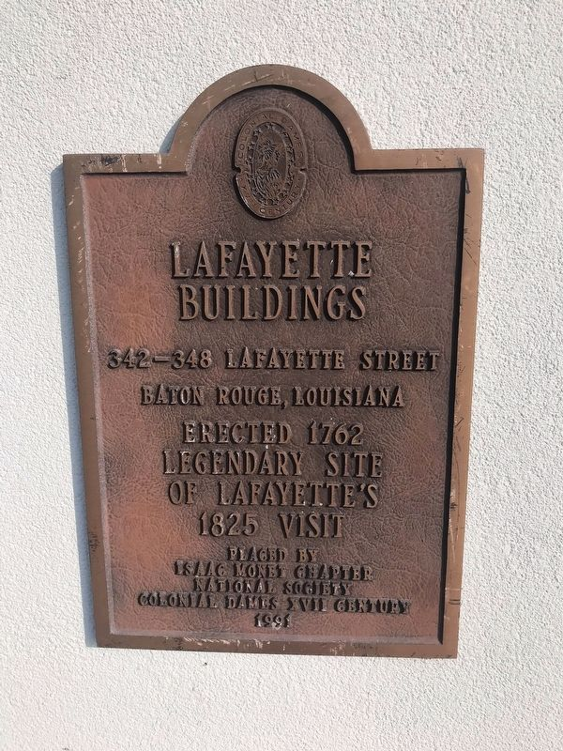 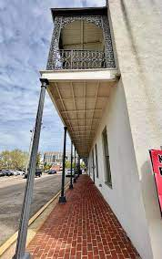 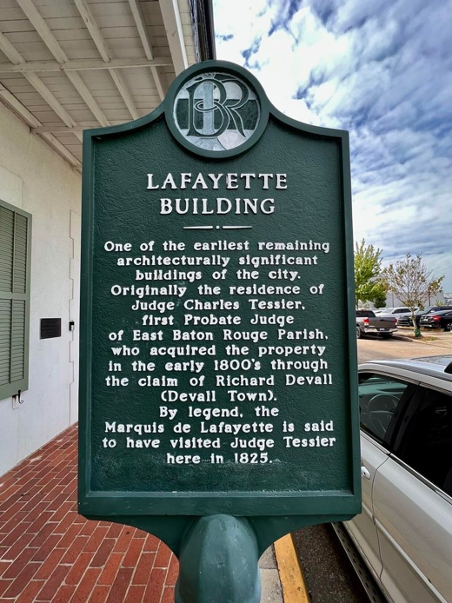

When Lafayette visited Baton Rouge, The Natchez docked and a carriage took Lafayette and his entourage on the River Road past Magnolia Mound Plantation to the only place large enough to hold a reception for him - Madame Legendre’s two-story inn on the corner of Florida and Fourth Streets. After his brief visit, Second Street was renamed Lafayette Street, and legend (but no proof has been found) has it that he delivered a speech from that street’s Tessier Building, also known as the Lafayette Building. The proud citizens of Baton Rouge have placed two markers at this location.

SO WHY VISIT MAGNOLIA MOUND?

Armand Gabriel Allard du Plantier (1753 – 9 Oct 1827) was a [French](https://en.wikipedia.org/wiki/French_Army) [cavalry](https://en.wikipedia.org/wiki/Cavalry) captain who served in the [American Revolutionary War](https://en.wikipedia.org/wiki/American_Revolutionary_War) as an [*aide-de-camp*](https://en.wikipedia.org/wiki/Aide-de-camp) to General [Lafayette](https://en.wikipedia.org/wiki/Gilbert_du_Motier,_marquis_de_Lafayette). In 1781, he moved to Louisiana (New Spain), settling on the plantation of his uncle, Claude Trénonay, in the area of Pointe Coupée on the Mississippi River. Soon after his wife’s death of yellow fever, in 1802 Duplantier married Constance Rochon Joyce, the widow of John Joyce, the original owner of Magnolia Mound Plantation near Baton Rouge.

Duplantier’s friendship with Lafayette continued after the Revolution, and when Lafayette was granted lands in Louisiana in 1803 in recognition of his service during the American Revolution, Duplantier was charged with acquiring them. Many letters were exchanged between Duplantier and President Madison regarding Lafayette’s bounty land.

In April 1825, Duplantier led the delegation that traveled to Mobile, Alabama to receive Lafayette and bring him to Louisiana, remaining with his old general all the way to Baton Rouge. Is it possible that Lafayette, accompanied by Duplantier, travelled by carriage within 60 yards from Duplantier’s home filled with his family, and they **didn’t** stop for a glass of wine and a rest? This would go against all social propriety of the times and is unimaginable given their great friendship!

Lafayette Vases in the Friends of Magnolia Mounds Collection