NEW ORLEANS WOMEN’S OPERA GUILD
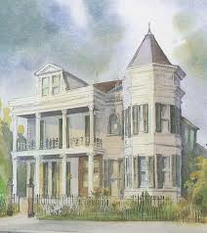

2504 Prytania, St. New Orleans, LA 70130
Friday April 11, 2025

Opera has long been part of the musical culture of New Orleans, Louisiana. Operas have regularly been performed in the city since the 1790s, making New Orleans the opera capital of 19th Century North America. The New Orleans Women’s Opera Guild is hosting us at their beautiful New Orleans mansion Museum on Prytania Street in the historic Garden District (formerly the City of Lafayette named in honor of Lafayette prior to it being incorporated into the City of New Orleans) that today serves as the home of the New Orleans Opera Women's Guild and the New Orleans Opera Association.

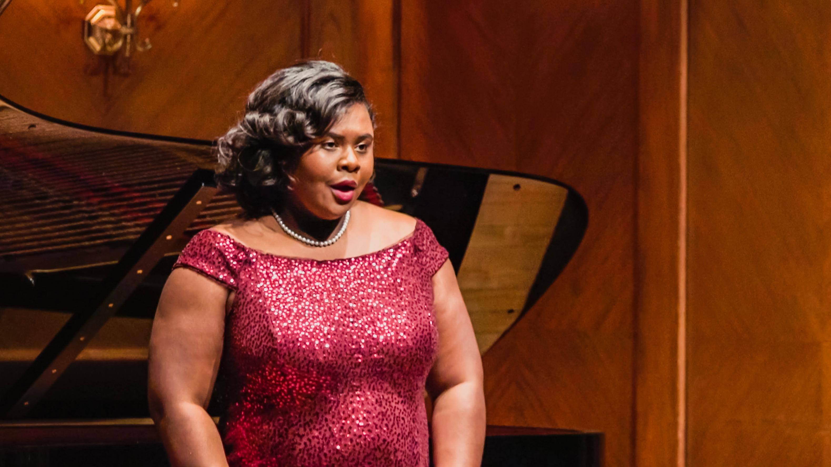

New Orleans local-turned-international star, Opera soprano Lindsey Reynolds will sing opera songs guaranteed to delight us.

Dr. Benjamin Franklin will make an appearance and take us on a walk down memory lane with Lafayette. We will have 5-star chef created heavy hors d'oeuvres and a limited bar. <Dress: For men, nice casual such as a sports coat with optional tie; for ladies, cocktail party attire. Period attire is always welcomed.> Dinner, opera, theatrical interpretation and round-trip motorcoach transportation is included.

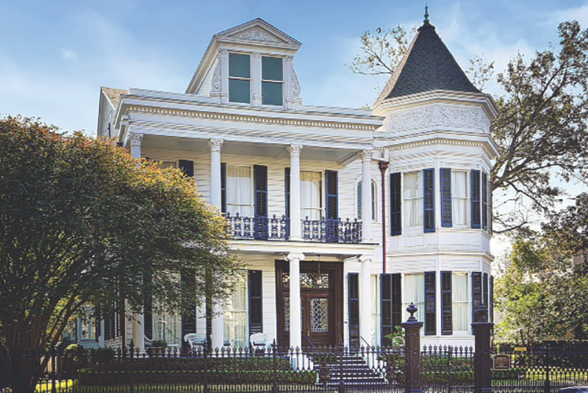

The Garden District was once the City of Lafayette until the City of New Orleans annexed it. The Garden District is one of New Orleans' most beautiful and famous neighborhoods, known for its history and luxurious mansions. The Women’s Opera Guild house is the only house in the entire Garden District open to the public.
The Women’s Opera Guild House was originally designed in the Greek Revival style by famous architect William A. Freret. In 1859, the home’s wealthy merchant owner apparently lost his fortune after the Civil War and couldn’t make the payments. Freret bought the house back at auction in 1867 for $30,700.
Fast-forward to a late 1890s makeover, no doubt by a different owner than architect Freret, and the house gained a turreted octagonal wing on one side and a far more eclectic personality.
Eventually, in 1944, the house was purchased for only $12,500 (the price again influenced by a war) by Dr. Herman de Bacchelle Seebold and his wife, Nettie Kenney Seebold, a globe-trotting couple whose lives were steeped in art and music as well as in material wealth, which they lavished on its decor.
As the years went by, Dr. Seebold passed away, and Mrs. Seebold followed in 1965. With no heir apparent, Mrs. Seebold’s hand-written will gave the glorious place and all its contents to the Opera Women’s Guild. A stipulation noted that the contents were not to be sold or removed.
Because of the low elevation and high water table, New Orleans residents were traditionally interred in “cities of the dead” – necropolises full of above-ground tombs and mausoleums. Of all the iconic graveyards in New Orleans, few can match the sheer gothic creepiness of Lafayette Cemetery No 1, where vines and vegetation grow up around ornate funerary monuments. This cemetery is just down the street from the Women’s Opera Guild House, but unfortunately, we do not have time to visit it.
LAFAYETTE’S CONNECTION
New Orleans was known as the opera capital of the United States throughout the 19th century. After a dinner and banquet hosted by the Masons, Lafayette visited the Orleans Theater which held an Opera - “Aline”, Queen of Golconda’ an opera in three acts by Pierre-Alexandre Monsigny to a libretto by Michel-Jean Sedaine based on a story by Stanislas-Jean de Boufflers. It was first performed in the Salle des Machines in Paris on 15 April 1766. After the opera, a piece written for the occasion “La Fayette in New Orleans” written by Mr. Guirot was performed.

