The FRENCH NATIONAL ORCHESTRA AUVERGNE-RHÔNE-ALPES in New Orleans!

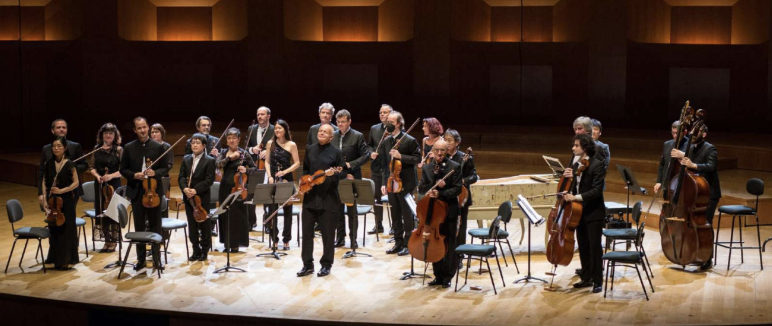

The Orchestra Nationale – Auvergne-Rhone-Alps who hail from the area of Chateau Chavaniac (Lafayette’s family ancestral home) will be performing an immersive experience on Sunday April 13, 2025 at 5 p.m. at the Orpheum Theater in New Orleans!

Led by conductor Thomas Zehetmair, the French National Orchestra of Auvergne-Rhône-Alpes will perform a wonderful program related to Lafayette's story and the historical period of his tour while an immersive sound & light experience will retrace the Marquis’ travels and incredible story. This 1 hour and 30 minute show is truly an experience that you won’t forget!

Virginie du Motier de La Fayette will introduce each concert event with a few words on the legacy of her ancestor and the importance of Lafayette’s heritage today more than ever. Virginie is a direct descendant of the Marquis de La Fayette through his son George Washington, named after his godfather. Gilbert du Motier de La Fayette was born on September 6, 1757; Virginie du Motier de La Fayette was born on August 29, 1970, so she is in the seventh generation. Also, she has been a member of the National Society of the Daughters of the American Revolution since April 1995 and currently serves as Registrar of the Rochambeau Chapter in Paris, France.

The American Friends of Lafayette – Louisiana Committee are glad to promote this once-in-a-lifetime time event you will not want to miss. The beautiful Orpheum Theater, which is on the National Register of Historic Places and recently celebrated its Centennial in 2021, is home to the Louisiana Philharmonic, and its architecture and design which is in the classic Beaux Arts style, serves as the perfect venue for the Orchestra Nationale – Auvergne-Rhone-Alps.

You will need to arrange your own transportation and purchase your tickets from the Orpheum Theater HERE: https://orpheumnola.net/

Here is a Teaser the Orchestra has released:
https://youtu.be/lKjcBv39CAk?si=aZ4Sn5hzir_S5w5a

