**NEW ORLEANS SPRING FIESTA ASSOCIATION**



Saturday April 12, 2025

826 St Ann St., New Orleans, LA 70116

The New Orleans Spring Fiesta Association is hosting us for “A Theatrical Evening with Lafayette” at their classic French Quarter early 19th century historic townhome.  Attendees will get to relive history by experiencing a wonderful evening including dinner, in the surroundings of a French Quarter home, of course with our favorite French general. A youth quartet of musical theater performers will entertain us with excerpts from Hamilton and they will remain in character while mingling with us. Dinner is included. This event venue is small and the maximum capacity will be met very quickly. <Dress: Dress: For men, nice casual such as a sports coat with optional tie; for ladies, cocktail party attire. Period attire is always welcomed.>

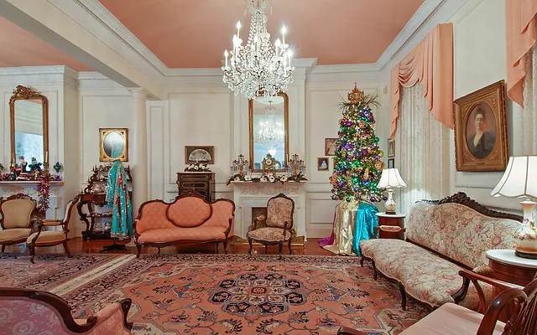

Interior View of the New Orleans Spring Fiesta Association Townhome

LAFAYETTE’S CONNECTION

Lafayette was pressed insistently to visit both the English and French theaters on the same evening. It was decided by lot which of the two he would visit first; chance favored the English language theater. At 7 o’clock pm Lafayette visited the American Theater/Theater of the Fauxbourg St. Mary which was showing the play “The Prisoner of Olmutz”. Midway through, Lafayette bowed to the American Theater audience and then hastened to the second event, where he was anxiously expected. At 9 o’clock pm at the Orleans Theater, Lafayette saw the last act of “School for Old Men” after which a cantata was executed, words written by Mr. Montmain and music by Mr. Cheret. Lafayette attended two theater performances when he was in New Orleans 200 years ago, so we will pay homage to those events.